The Chinese Calendar
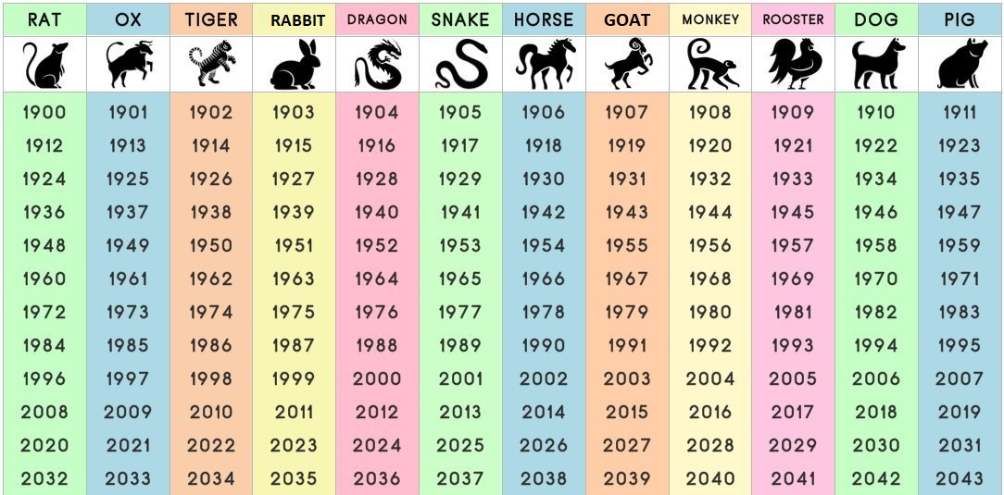
Characteristics:
Rat: energetic, talkative, ambitious, imaginative, charming
Ox: honest, dependable, tolerant, hard-working, patient
Tiger: emotional, sensitive, daring, brave, sympathetic
Rabbit: articulate, peaceful, virtuous, reserved, kind
Dragon: trustworthy, brave, energetic, excitable, sensitive
Snake: determined, passionate, calm, wise, sympathetic
Horse: independent, cheerful, popular, talented, perceptive
Goat: artistic, charming, loving, compassionate, gentle
Monkey: confident, flexible, inventive, enthusiastic, clever
Rooster: kind, hard-working, adventurous, punctual, talented
Dog: loyal, helpful, honest, affectionate, generous
Pig: helpful, forgiving, honest, sincere, chivalrous

Compatibility Chart

